Hypothesis in machine learning:

In a machine learning problem where the input is denoted by **x** and the output is *y*  
  
In order to do machine learning, there should exist a relationship (pattern) between the input and output values. Lets say that this the function  
*y*=*f*(**x**), this known as the **target function.**  
  
However, *f*(.) is unknown function to us.  so machine learning algorithms try to guess a ``hypothesis'' function *h*(**x**) that approximates the unknown *f*(.), the set of all possible hypotheses is known as the Hypothesis set *H*(.), the goal is the learning process is to find the final hypothesis that best approximates the unknown target function.  
  
Different machine learning models have different hypothesis sets, For example the 2d- perceptron has the hypothesis set  
*H*(**x**)={*sign*(*w*1∗*x*1+*w*2∗*x*2+*w*0)∀*w*0,*w*1,*w*2}

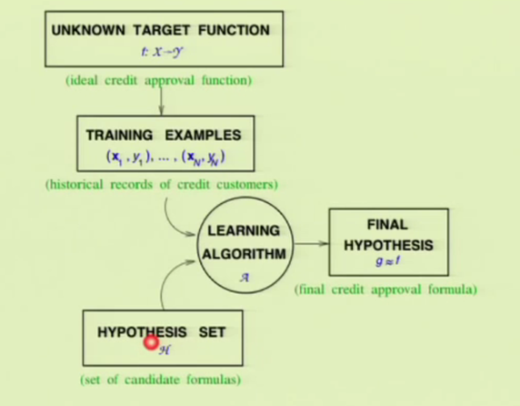

Terminology:

Essentially, the terms "classifier" and "model" are synonymous in certain contexts; however, sometimes people refer to "classifier" as the learning algorithm that learns the model from the training data. To makes things more tractable, let's define some of the key terminology:

* *Training sample:* A training sample is a data point *x* in an available training set that we use for tackling a predictive modeling task. For example, if we are interested in classifying emails, one email in our dataset would be one training sample. Sometimes, people also use the synonymous terms *training instance* or *training example*.
* *Target function:* In predictive modeling, we are typically interested in modeling a particular process; we want to learn or approximate a particular function that, for example, let's us distinguish spam from non-spam email. The *target function* *f(x) = y* is the true function *f* that we want to model.
* *Hypothesis:* A hypothesis is a certain function that we believe (or hope) is similar to the true function, the *target function* that we want to model. In context of email spam classification, it would be the *rule* we came up with that allows us to separate spam from non-spam emails.
* *Model:* In machine learning field, the terms *hypothesis* and *model* are often used interchangeably. In other sciences, they can have different meanings, i.e., the hypothesis would be the "educated guess" by the scientist, and the *model* would be the manifestation of this *guess* that can be used to test the hypothesis.
* *Learning algorithm:* Again, our goal is to find or approximate the *target function*, and the learning algorithm is a set of instructions that tries to *model* the target function using our training dataset. A learning algorithm comes with a *hypothesis space*, the set of possible hypotheses it can come up with in order to model the unknown target function by formulating the *final hypothesis*
* *Classifier:* A classifier is a special case of a *hypothesis* (nowadays, often learned by a machine learning algorithm). A *classifier* is a *hypothesis* or *discrete-valued function* that is used to assign (categorical) class labels to particular data points. In the email classification example, this classifier could be a hypothesis for labeling emails as spam or non-spam. However, a *hypothesis* must not necessarily be synonymous to a *classifier*. In a different application, our *hypothesis* could be a function for mapping study time and educational backgrounds of students to their future SAT scores.

So, we can say that a *classifier* is a special case of a *hypothesis* or *model*: a classifier is a function that assigns a class label to a data point.